Agile Adapter Stress Testing Program

# Flows

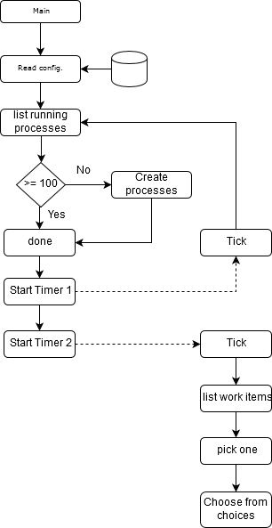

# Configurations

Configurations are written in a file “AA_StressTest.config” with the following format.  
Unwritten settings are ignored and will be used default value.

general: Set general configurations

|  |  |  |  |
| --- | --- | --- | --- |
| Name | Type | Default | Description |
| baseUrl | String | “http://interstagedemo:  49950/aa/” | Base url of the server that AA is running. /aa/… will be added to access the REST API.  *Slash at the end is required. |
| Tenant | String | “Default” | Tenant name. |
| appName | String | “RandomWalk” | Application name that the test program accesses. |
| processDefinition | int | 15 | Process definition ID. |
| baseProcessName | String | “RandWkAutoTest_” | New process instance will be created with this string followed by number |
| runningProcessCount | int | 100 | Number of process to keep active during the test. If the number drops below, new processes will be created. |
| taskCompletionInterval | int | 500 | How often a task is completed in milliseconds |

users: Define users who perform works.

|  |  |  |  |
| --- | --- | --- | --- |
| Name | Type | Default | Description |
| name | String | “” | Name of the user. If not defined, “username” part of the “authString” is used. |
| authString | String | *Required* | Basic authentication string.  *username:password*  Ex. alex@us.fujitsu.com:Fujitsu1 |

{  
 main :  
 {  
 “runningProcessCount” : “100”,   
 “taskCompletionInterval”:”500”,  
 },  
 users:  
 [  
 { “name” : “alex”, “authString”: “alex@example.com:Fujitsu1” },  
 { “name” : “betty”, “authString”: “betty@example.com:Fujitsu1” }  
 ]  
 }